**The 8 Phases of software development cycle are as below: -**

**Phase 1- Planning**

*Planning a project when you investigate a client's needs and analyse the results to outline*

*and propose a software solution.*

*What has to be done?*

In this project the client would like a Help Desk ticketing system prototype developed.

The Help Desk ticketing system should handle tickets from **internal customers only**.

Tickets will be requested for assistance **from** the Help Desk **by** staff members of the organisation.

**Phase 2 - Requirement Analysis**

*Requirements analysis is the practice of unpacking why the system is needed and what it is*

*intended to achieve. Functional requirements, Non-functional requirements, Compliance*

*requirements Constraints*.

**Clients Requirements of the Help Desk Ticketing System**

**Tickets:**

* Tickets can be submitted by providing all the following information:
* Staff ID,
* Ticket creator name,
* Contact email
* Description of the issue

Internal Tickets’ ticket number should be assigned automatically using the **counter static field plus 2000.**

**Technical Requirements of the Help Desk Ticketing System**

* The Ticket class should contain common ticket information in the Ticket class.
* The Ticket class should also have method allowing the staff to submit ticket and the IT team to respond to the tickets, specifically resolve, reopen and provide a response to the ticket.
* The Ticket class should contain a method for resolving password change requests. As well as calling the method that would generate the new password, it should set up a response for the ticket and change the ticket status to closed.
* There should be a method to print information for all the ticket objects.
* The TicketStats method in Ticket class should contain information on ticket statistics and shall be able to return the statistics information.
* The main class, containing the Main method.

**Task 3: Solution Design**

To design a high level solution that meets the client's requirements.



**Task 4: Detailed Design**

In this task, individual elements of the overall system are designed in more detail, in preparation for coding and implementation.

for example, user interactions and screen layouts are designed for a user story or a use case scenario, detailed data modelling takes place, error handling is specified, as well as test case

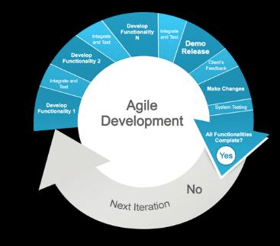

**Task 5: Construction**

The focus of the Construction phase is to develop the system to the point where it is ready for pre-production testing.

The code is written according to the design, the frameworks and libraries are set in place, and database tables created and populated where needed.

**Task 6: Testing**

Testing starts once the coding is complete and the modules are released for testing. In this phase, the developed software is tested thoroughly and any defects found are assigned to developers to get them fixed.

**Task 7: Deployment**

Once the product is tested, it is deployed in the production environment or It includes installation of the software, any data migration or conversion, delivery of some form of operation and user guide, training sessions for users, and a planned transition from any old system/s to the new system

**Task 8: Maintenance**

After the deployment of a product on the production environment, maintenance of the product i.e. if any issue comes up and needs to be fixed or any enhancement is to be done is taken care by the developers